Project Design Phase-II
Technology Stack (Architecture & Stack)

Date | 03 October 2026
Team ID | SWTID-2026-6867
Project Name | Streamlining IT Procurement: Automating Standard Laptop Orders with Flow Designer
Maximum Marks | 4 Marks

Technical Architecture:
The Deliverable shall include the architectural diagram as below and the information as per the table1 & table 2
Architecture: Standard laptop order automation on the ServiceNow cloud platform
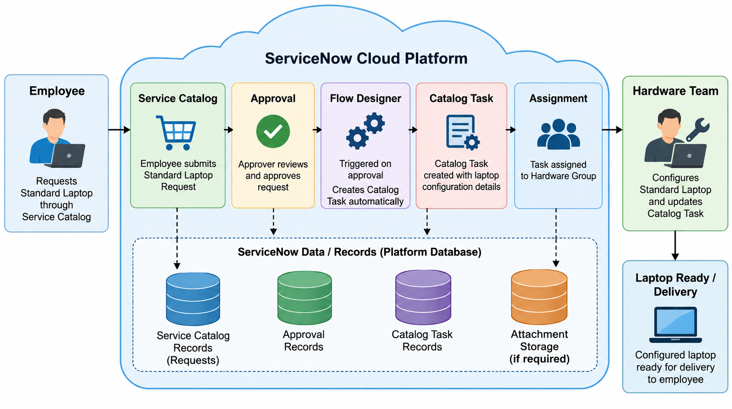
Guidelines:
Include all the processes (As an application logic / Technology Block)
Provide infrastructural demarcation (Local / Cloud)
Indicate external interfaces (third party API’s etc.)
Indicate Data Storage components / services
Indicate interface to machine learning models (if applicable)
Table-1 : Components & Technologies:
S.No | Component | Description | Technology
 | User Interface | Interface through which employees submit and view standard laptop requests. | ServiceNow Service Catalog
 | Application Logic-1 | Handles the automation triggered after the standard laptop request is approved. | ServiceNow Flow Designer
 | Application Logic-2 | Handles the approval of the submitted standard laptop request. | ServiceNow Approval Workflow
 | Application Logic-3 | Creates and assigns the laptop configuration task to the Hardware group. | ServiceNow Catalog Task
 | Database | Stores ServiceNow request, approval, and task records related to the laptop procurement process. | ServiceNow Platform Database
 | Cloud Database | Cloud-based storage of application and transaction records within the ServiceNow platform. | ServiceNow Cloud Platform Data Storage
 | File Storage | Stores attachments associated with requests or tasks when required. | ServiceNow Attachment Storage
 | External API-1 | No external API is required for the standard laptop procurement automation. | Not Applicable
 | External API-2 | No external API is required for the standard laptop procurement automation. | Not Applicable
 | Machine Learning Model | Machine learning is not required for this project. | Not Applicable
 | Infrastructure (Server / Cloud) | The application is implemented and executed on the ServiceNow cloud platform. | ServiceNow Cloud Platform
Table-2: Application Characteristics:
S.No | Characteristics | Description | Technology
 | Open-Source Frameworks | No separate open-source application framework is required for this ServiceNow-based solution. | ServiceNow Platform
 | Security | Access to requests, approvals, and configuration tasks is controlled through authorized ServiceNow users and role-based access. | ServiceNow Role-Based Access Control (RBAC)
 | Scalable Architecture | The ServiceNow cloud platform can support an increasing number of standard laptop requests while Flow Designer automates repetitive processing. | ServiceNow Cloud Platform and Flow Designer
 | Availability | The solution is hosted on the ServiceNow cloud platform so employees and IT teams can access the request and automation process when required. | ServiceNow Cloud Platform
 | Performance | Flow Designer automatically creates and assigns the Catalog Task after approval, reducing unnecessary manual processing and processing delays. | ServiceNow Flow Designer

References:
1. ServiceNow – Flow Designer: https://www.servicenow.com/in/products/platform-flow-designer.html
2. ServiceNow – Service Catalog: https://www.servicenow.com/products/it-service-automation-applications/service-catalog.html
3. ServiceNow Developers: https://developer.servicenow.com/
4. ServiceNow – Now Platform: https://www.servicenow.com/products/now-platform.html

